- Name: Rudra Satish Akalade.
- Branch: IT Div: B Roll No.: 88
Assignment No. : 02 **********GitHub**********
- What is GitHub?
GitHub is an online platform used to store, manage, share, and collaborate on software projects and code.
It works together with Git, which is a version-control system.
  - Git → Tracks changes in your code.
  - GitHub → Stores your Git projects online and helps people collaborate.
- Important GitHub Terms :

• Repository
A repository (repo) is a project folder stored using Git.
A repository can contain your source code, images, documentation, and other project files.

• Commit
A commit saves a set of changes in Git.
"Initial commit" is the message describing what you changed.

• Branch
A branch is a separate line of development.
You can develop a feature on a branch without directly changing the main project.

• Main
Main is commonly the primary branch of a repository.
Older repositories may use master.
- Clone
Clone downloads a GitHub repository to your computer.
- Push
Push uploads your local commits to GitHub.
- Pull
Pull downloads changes from GitHub and integrates them into your local branch.

• Fork
A fork creates your own copy of someone else's GitHub repository under your account.
It is commonly used when contributing to projects you don't directly control.
- Pull Request
A Pull Request (PR) is a request to merge your changes into another branch/repository.
- Merge
Merge combines changes from one branch into another.

• README
README.md is a documentation file that explains your project.
It can contain:
- Project name
- Description
- Features
- Installation steps
- How to run the project
- Screenshots
- Technologies used
3. Important Git Commands :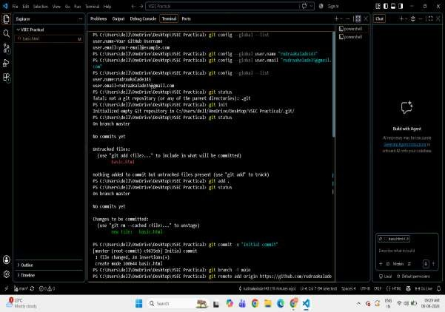

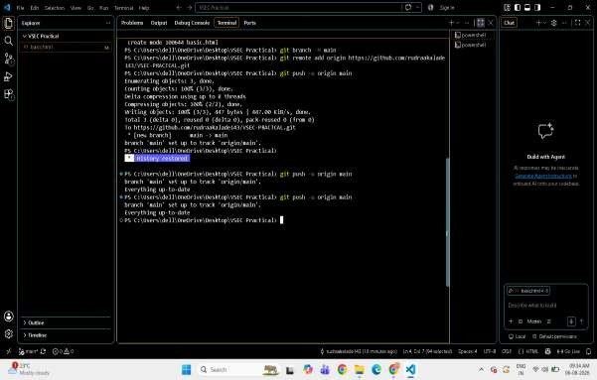

GitHub Features
Some important GitHub features are:
- Repositories – Store projects.
- Branches – Work on different versions.
- Commits – Record changes.
- Pull Requests – Propose changes.
- Issues – Track bugs and tasks.
- Actions – Automate workflows.
- Pages – Host websites.
- Releases – Publish project versions.
- Projects – Organise tasks and project work.
- Code Review – Review changes before merging.
- Collaboration – Multiple people can work together.
- README – Provide project documentation.

